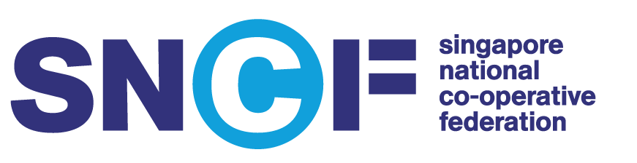
SNCF Co-op Scholarship 2019
Application Checklist
Applicatio
n Checklist

- Thank you for your interest in the SNCF Co-op Scholarship.
- Please attach this checklist with your scanned supporting documentations and submit them to SNCF secretariat via the Brightsparks portal. Only online submissions will be accepted.
- Please cross (x) the relevant boxes to indicate the documents you have submitted.
- Please label all scanned documents correctly.
- SNCF Secretariat will contact you if we require any additional information or clarifications.
Name: ________________________________________ Gender: F/M NRIC No: _________________________

Email: ____________________________________ Contact No. (Home/Mobile): ____________________________

Please cross (x) the boxes and send in clear copies of all the following mandatory supporting documents, where applicable:
Birth Certificate
NRIC / Passport

Secondary 3 and 4 Year-end result slips (For IB / IP Students)
Secondary 3 and 4 Character and Leadership Education End-of-Year Report (including teacher’s comments)
Secondary School CCA records (including CIP certificate, if applicable)
GCE ‘A’ and ‘AO’ level certificate(s) or results slip(s)
IB results slip (For IB Students)
Diploma certificate or results slip (For NUS High School Students)
Polytechnic Diploma transcripts or results slip
Junior College or Polytechnic CCA records (including CIP certificate, if applicable)

University transcripts or results slips
Testimonial(s) / Certificate(s) for industrial / professional attachments(s)
Any other documents to support your application

For enquiries on your online submission:
Email: germainechan@sncf.org.sg
Subject: SNCF Co-op Scholarship 2019 – (Insert your full name)

